Update New Feature.

For OpenCV subgroup.
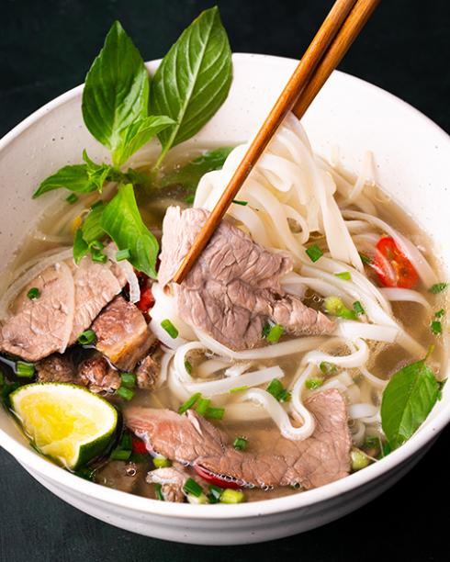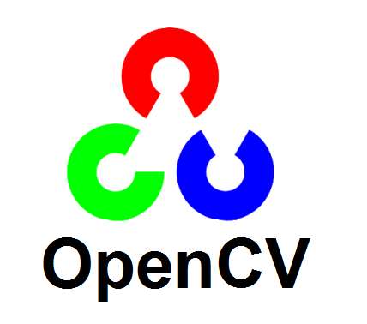

Task1: Make a feature of moving the cursor by middle finger on webcam.

Task2: Click feature.

- We would be happy and proud of you guys to come up more tasks after finished three tasks given.

For Media dawgs:

Task1: Making a feature of switching tabs.

Task2: making a feature of reloading tabs.

